GET DATA
/TYPE=XLSX
/FILE='C:\Users\efilguer\Downloads\Sales.xlsx'
/SHEET=name 'Sales'
/CELLRANGE=FULL
/READNAMES=ON
/DATATYPEMIN PERCENTAGE=95.0
/HIDDEN IGNORE=YES.
EXECUTE.
DATASET NAME DataSet1 WINDOW=FRONT.
EXAMINE VARIABLES=Profit
/PLOT BOXPLOT HISTOGRAM NPPLOT
/COMPARE GROUPS
/PERCENTILES(5,10,25,50,75,90,95) HAVERAGE
/STATISTICS DESCRIPTIVES
/CINTERVAL 95
/MISSING LISTWISE
/NOTOTAL.

Explore

Notes
Output Created |  | 04-MAR-2019 11:07:19
Comments
Input | Active Dataset | DataSet1
Input | Filter | <none>
Input | Weight | <none>
Input | Split File | <none>
Input | N of Rows in Working Data File | 60
Missing Value Handling | Definition of Missing | User-defined missing values for dependent variables are treated as missing.
Missing Value Handling | Cases Used | Statistics are based on cases with no missing values for any dependent variable or factor used.
Syntax |  | EXAMINE VARIABLES=Profit  /PLOT BOXPLOT HISTOGRAM NPPLOT  /COMPARE GROUPS  /PERCENTILES(5,10,25,50,75,90,95) HAVERAGE  /STATISTICS DESCRIPTIVES  /CINTERVAL 95  /MISSING LISTWISE  /NOTOTAL.
Resources | Processor Time | 00:00:01.08
Resources | Elapsed Time | 00:00:00.70

[DataSet1]

Case Processing Summary
 | Cases
 | Valid |  | Missing |  | Total
 | N | Percent | N | Percent | N | Percent
Profit | 60 | 100.0% | 0 | 0.0% | 60 | 100.0%

Descriptives
 |  |  | Statistic | Std. Error
Profit | Mean |  | $4,239.1646 | $750.29102
Profit | 95% Confidence Interval for Mean | Lower Bound | $2,737.8357
Profit | 95% Confidence Interval for Mean | Upper Bound | $5,740.4934
Profit | 5% Trimmed Mean |  | $3,459.5842
Profit | Median |  | $1,662.4300
Profit | Variance |  | 33776197.024
Profit | Std. Deviation |  | $5,811.72926
Profit | Minimum |  | $40.60
Profit | Maximum |  | $25,379.34
Profit | Range |  | $25,338.74
Profit | Interquartile Range |  | $5,681.45
Profit | Skewness |  | 2.040 | .309
Profit | Kurtosis |  | 4.322 | .608

Percentiles
 |  | Percentiles
 |  | 5 | 10 | 25 | 50 | 75
Weighted Average(Definition 1) | Profit | $59.3590 | $102.6340 | $389.3400 | $1,662.4300 | $6,070.7950
Tukey's Hinges | Profit |  |  | $412.2000 | $1,662.4300 | $5,880.5900

Percentiles
 |  | Percentiles
 |  | 90 | 95
Weighted Average(Definition 1) | Profit | $12,225.7460 | $16,833.2660
Tukey's Hinges | Profit

Tests of Normality
 | Kolmogorov-Smirnovª |  |  | Shapiro-Wilk
 | Statistic | df | Sig. | Statistic | df | Sig.
Profit | .235 | 60 | .000 | .726 | 60 | .000

a. Lilliefors Significance Correction

Profit

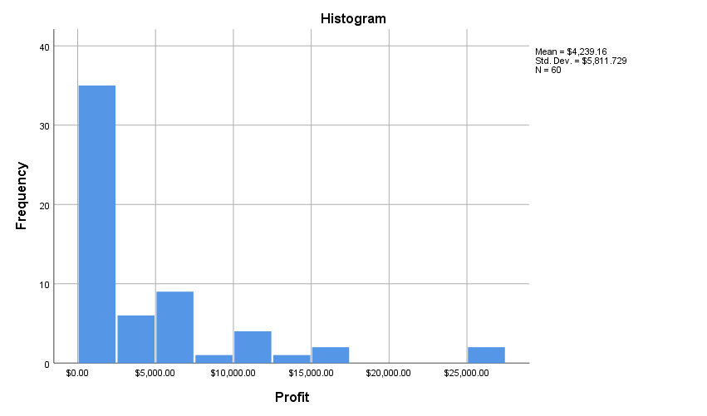

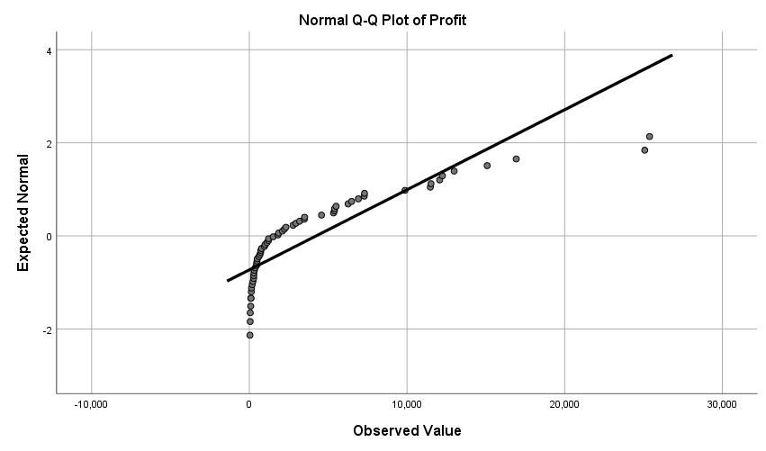

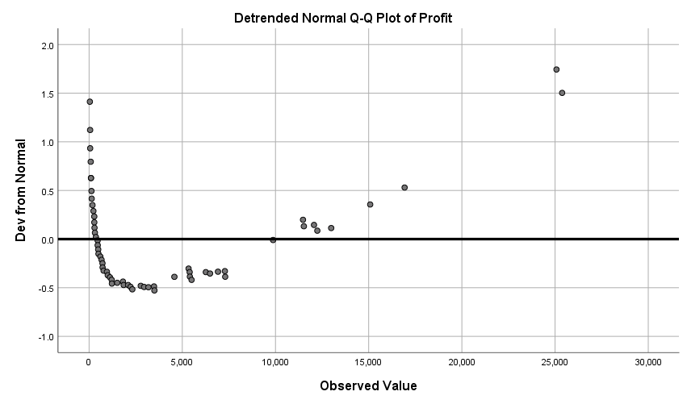

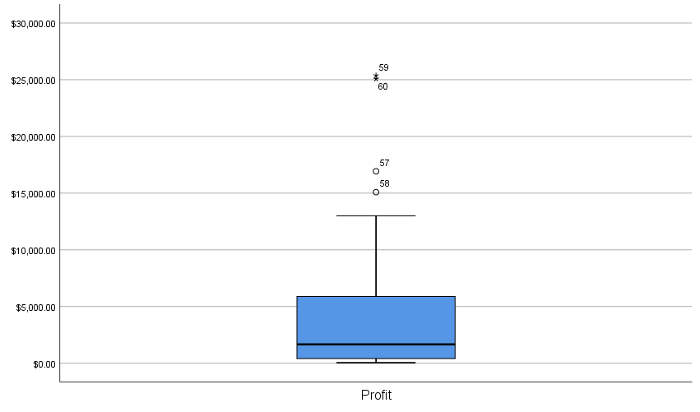

T-TEST
/TESTVAL=0
/MISSING=ANALYSIS
/VARIABLES=Profit
/CRITERIA=CI(.95).

T-Test

Notes
Output Created |  | 04-MAR-2019 11:12:10
Comments
Input | Active Dataset | DataSet1
Input | Filter | <none>
Input | Weight | <none>
Input | Split File | <none>
Input | N of Rows in Working Data File | 60
Missing Value Handling | Definition of Missing | User defined missing values are treated as missing.
Missing Value Handling | Cases Used | Statistics for each analysis are based on the cases with no missing or out-of-range data for any variable in the analysis.
Syntax |  | T-TEST  /TESTVAL=0  /MISSING=ANALYSIS  /VARIABLES=Profit  /CRITERIA=CI(.95).
Resources | Processor Time | 00:00:00.00
Resources | Elapsed Time | 00:00:00.00

One-Sample Statistics
 | N | Mean | Std. Deviation | Std. Error Mean
Profit | 60 | $4,239.1646 | $5,811.72926 | $750.29102

One-Sample Test
 | Test Value = 0
 | t | df | Sig. (2-tailed) | Mean Difference | 95% Confidence Interval of the Difference
 |  |  |  |  | Lower | Upper
Profit | 5.650 | 59 | .000 | $4,239.16458 | $2,737.8357 | $5,740.4934

T-TEST
/TESTVAL=4500
/MISSING=ANALYSIS
/VARIABLES=Profit
/CRITERIA=CI(.95).

T-Test

Notes
Output Created |  | 04-MAR-2019 11:16:36
Comments
Input | Active Dataset | DataSet1
Input | Filter | <none>
Input | Weight | <none>
Input | Split File | <none>
Input | N of Rows in Working Data File | 60
Missing Value Handling | Definition of Missing | User defined missing values are treated as missing.
Missing Value Handling | Cases Used | Statistics for each analysis are based on the cases with no missing or out-of-range data for any variable in the analysis.
Syntax |  | T-TEST  /TESTVAL=4500  /MISSING=ANALYSIS  /VARIABLES=Profit  /CRITERIA=CI(.95).
Resources | Processor Time | 00:00:00.00
Resources | Elapsed Time | 00:00:00.00

One-Sample Statistics
 | N | Mean | Std. Deviation | Std. Error Mean
Profit | 60 | $4,239.1646 | $5,811.72926 | $750.29102

One-Sample Test
 | Test Value = 4500
 | t | df | Sig. (2-tailed) | Mean Difference | 95% Confidence Interval of the Difference
 |  |  |  |  | Lower | Upper
Profit | -.348 | 59 | .729 | -$260.83542 | -$1,762.1643 | $1,240.4934
- We don’t use the Ci when dealing with t-tests because it uses the mean difference of mean and standard dev. If we do this, we get a negative number
Hypothesis testing
- State your claim (hypothesis)
- Choose level of significance
- Calculate the test statistics
- Calculate P-value and compare to alpha
- Conclude based on results
- if P-value > alpha= reject the null hypothesis
Problem1 example: Refer to slides

Given:
Mean= 6.7
SD = 1.2
N= 30
Z= 1.96

CI
=mean +- z*( s/sqrt(n))
= 6.7+-(1.96(a.2/sqrt(30))
=6.7+-(1.96*0.219)
Upper bound= 7.13
Lower bound= 6.27

- How do we use hypothesis? Q: is it faster
- Null hypothesis: mean =7.5
- Alternative hypothesis: mean less than 7.5
- Conclusion:
-We are 95% confident that the true average time for the new server is between 6.27 and 7.13 we would expect it to be of lower average in minutes
- Because original time of 7.5 minutes, is not included in the interval of 6.27 and 7.13, we conclude that the new server is faster, or the upgraded is faster. So we reject the null hypothesis that states that there’s no difference between the speed of the servers.
-since the calculated value is significantly higher than the calculated average, we can reject the null hypothesis that states that the new and old server speed is the same.
- you can also calculate the z-value to check if our value is way beyond the allowed standard deviations
Z=Place the range in place of the mean from our formula= (6.7-7.5)/1.2/SQRT(30)= -3.65
P-value:
Probability that z is less than the computed z value of 3.65
=NORMDIST(-3.65,0,1,TRUE)
= NORMDIST(z value, mean , SD, True)
P-value= 0.00013
- This means that the probability that this is calculated by chance is 1 in 10,000
- P-value is calculated using the z-value
- P-value is less than alpha (0.05), we reject the null hypothesis or that it is not statistically significant.\
If we were to sat that the probability of z is greater than z value
- (1-P(z<-3.65)
Z-tests for a population average in large samples

One tailed= equal to
Two tailed= not equal to

Ex: task completion time
4.5 : null hypothesis
Sample= 75 users
Mean= 4.2 sec
SD= 1.3 sec
** remember if confidence interval is not give; we always use 95%
Can you conclude that the new interface allows users to complete task in a shorter time?
Use a statistical test to answer your question
- state Hypothesis
Ho= mean= 4.5
Ha= mean less than 4.5
Alpha= 0.05: based on your confidence level of 95
- population mean- sample mean/ standard error
z = 4.2-4.5/(1.3/sqrt(75))
- Use this value of z to find the p-value
- Since this is a less than problem, we use NORMDIST
Homework:
Ho: mean= 4500
Ha: mean less than 4500
Confidence level= 95%
Alpha= 5% or 0.05
N= 60
SD= 5811.72926
= 4239.1646
= 4239.1646-4500/ 5811.72926/sqrt(60)
= -260.83542/750.29102= -0.348 (given in the homework)
=
One-Sample Test
 | Test Value = 4500
 | t |  | df |  | Sig. (2-tailed) |  | Mean Difference |  | 95% Confidence Interval of the Difference
 |  |  |  |  |  |  |  | Lower |  | Upper
Profit | -.348 | 59 |  | .729 |  | -$260.83542 |  | -$1,762.1643 |  | $1,240.4934

-Would we reject or not reject the null hypotheis?
- it is two standard deviations away, it is within our 95% range, so we would not reject the null hypothesis.

